Little Hands at Work and Play
Daily Schedules
(Schedules will vary some by location)

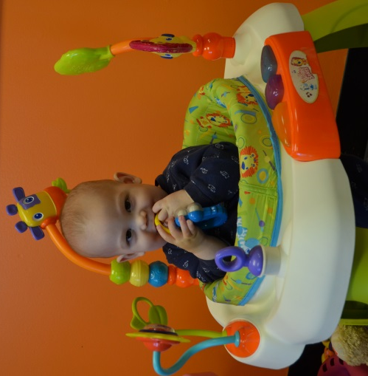

Infant Schedule
6:00-7:30 Arrival/ Free Play
7:30-8:30 Breakfast
8:00-9:00 Diapers/ Exercises/ Art
9:00-10:00 Nap
10:00-10:30 Diapers
10:30-11:00 Tummy Time
11:00-11:30 Lunch
11:30-12:00 Fine Motor
12:00- 12:30 Music/ Diapers
12:30-1:00 Story Time
1:00-3:00 Nap
3:00-3:30 Diapers
3:30-4:00 Snack
4:00-4:30 Large Motor
4:30-5:00 Group Activities
5:00-5:30 Diapers/ Free Play
5:30-6:00 Departure
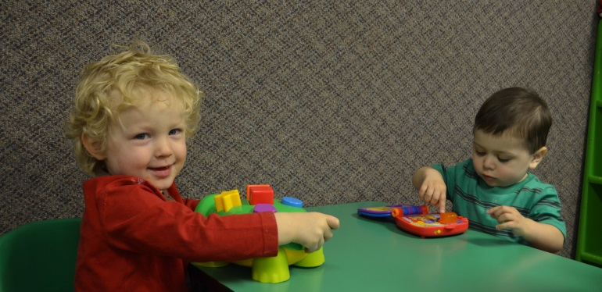

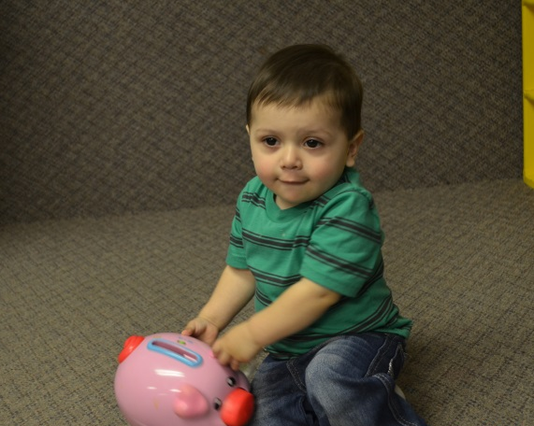

One’s/Toddler Schedule
6:00-7:30 Arrival
7:30-8:30 Breakfast
8:00-9:00 Diapers/ Potty Time/ Puzzle Time/ Books
9:00-9:20 Circle Time
9:20-10:00 Art and Center Time
10:00-10:15Diapers/ Potty Time
10:15-10:45 Math/ Science/ Cooking
10:45-11:00 Story Time/ Flashcards
11:00-11:30 Lunch
11:30-12:00 Music Time
12:00-12:45 Diapers/ Potty Time/ Outside/ Large Motor
12:45-2:45 Nap
2:45-3:00 Diapers/ Potty Time
3:00-3:30 Snack
3:30-4:15 Centers/ Art
4:15-4:30 Diapers/ Potty Time
4:30-5:15 Large Motor/ Exercise/ Outside Time
5:15-5:30 Group Activity/ Book Time
5:30-6:00 Departure

Preschool Schedule
6:00-8:30 Arrival/ Breakfast/ Free Play
8:30-9:00 Book/ Puzzles/ Bathrooms
9:00-9:30 Circle Time: Pledge, Calendar, Weather, Story, Explain Art & Areas
9:30-10:30 Centers/ Art
10:30-11:00 Math or Science or Cooking (Tuesday & Thursday)/ Bathrooms
11:00-11:30 Circle Time: Letter of the Week/ Music
11:30-12:00 Outside Time/ Large Motor
12:00-12:30 Lunch
12:30-1:00 Story Time/ Bathrooms
1:00-3:00 Rest Time
3:00-3:30 Circle Time/ Bathroom
3:30-4:00 Snack
4:00-5:00 Outside Time (Weather Permitting)/ Large Motor/ Areas/ Art
5:00-5:30 Centers/ Bathroom
5:30-6:00 Quiet Time/ Departure

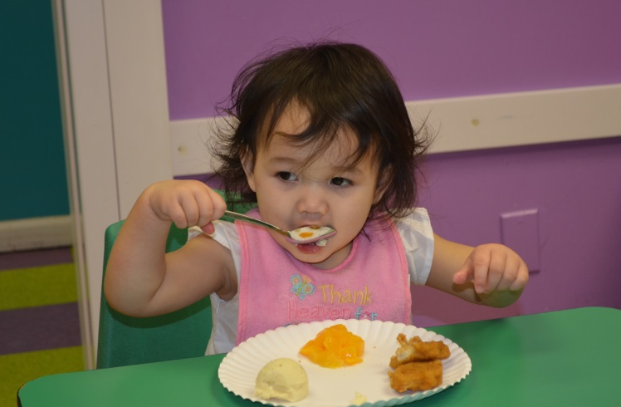

School Age Schedule: (Days off during the school year/at the center all day)
6:00 am – 7:30 am: Arrival/Free Play
7:30 am – 8:30 am: Breakfast
8:30 am – 9:00 am: Books and Puzzles
9:00 am – 9:30 am: Circle Time
9:30 am – 10:00 am: Stretch and Move/Music/Dance/Interactive Story
10:30 am – 11:00 am: Science/Cooking/Math
11:00 am – 11:30 am: Center Play
11:30 am – 12:00 pm: Group Art activity
12:00 pm – 12:30 pm: Lunch
12:30 pm – 1:00 pm: Outside play/ Outside Group Games
1:00 pm – 1:30 pm: Continue outside Play if it’s nice out/Large Group Activity inside
1:30 pm – 2:00 pm: Journal
2:00 pm – 3:00 pm: Art/Quiet Center Play/Board Games
3:30 pm – 4:00 pm: Snack with Pre-K
4:00 pm – 4:30 pm: Afternoon Activity with theme
4:30 pm – 5:00 pm: Outside Time/ Large Group Activity
5:00 pm – 6:00 pm: Closing/Free Play

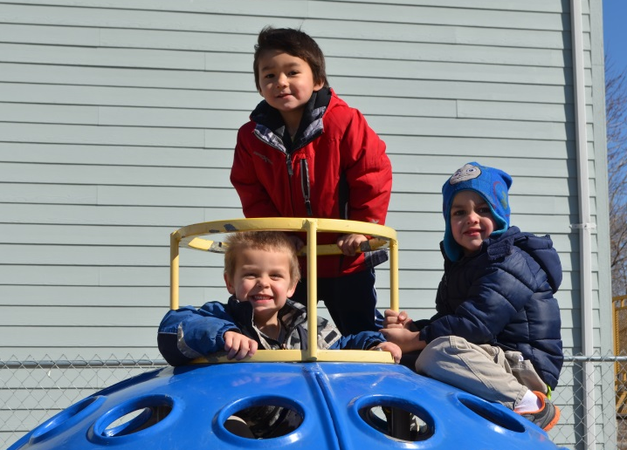

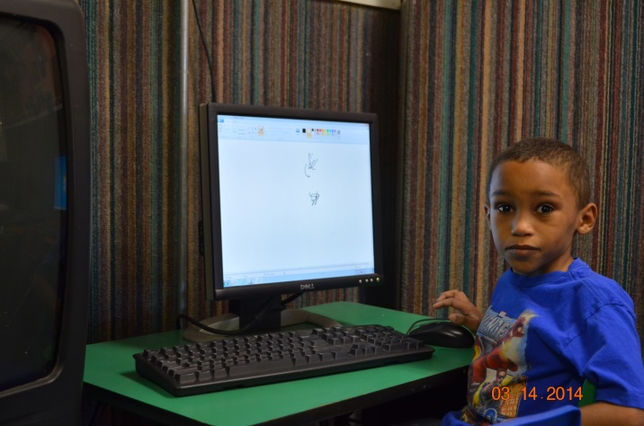

School Age Schedule w/ Morning Field Trip
6:00 am – 7:30 am: Arrival/Free Play
7:30 am – 8:00 am: Breakfast
8:00 am – 8:30 am: Bathroom/Sun Screen/Fill Water Bottles
8:30 am – 12:00 pm: Field Trip
12:00 pm – 12:30 pm: Lunch
12:30 pm – 1:00 pm: Outside play/ Outside Group Games
1:00 pm – 1:30 pm: Continue outside Play if it’s nice out/Large Group Activity inside
1:30 pm – 2:00 pm: Journal
2:00 pm – 3:00 pm: Art/Science/Cooking/Quiet Center Play/Board Games
3:30 pm – 4:00 pm: Snack with Pre-K
4:00 pm – 4:30 pm: Afternoon Activity with theme
4:30 pm – 5:00 pm: Outside Time/ Large Group Activity
5:00 pm – 6:00 pm: Closing/Free Play

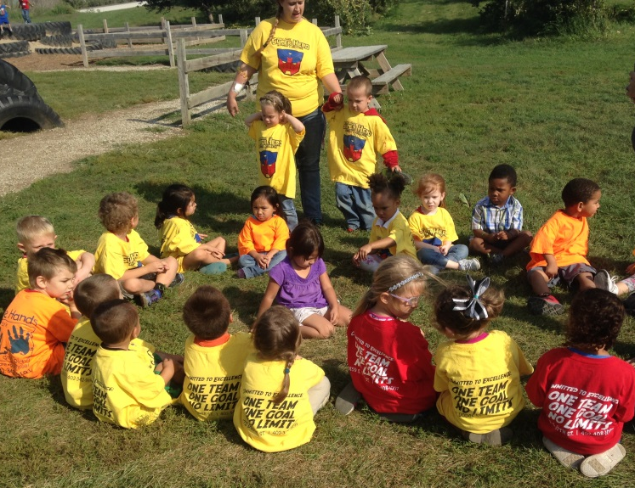
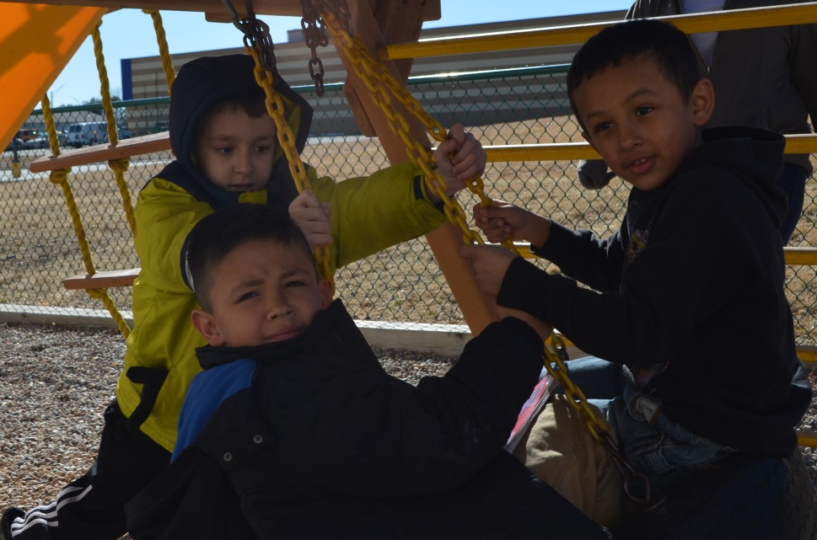

School Age Schedule w/ Afternoon Field Trip
6:00 am – 7:30 am: Arrival/Free Play
7:30 am – 8:00 am: Breakfast
8:30 am – 9:00 am: Books and Puzzles
9:00 am – 9:30 am: Circle Time
9:30 am – 10:00 am: Stretch and Move/Music/Dance
10:30 am – 11:00 am: Science/Cooking/Math
11:00 am – 11:30 am: Center Play
11:30 am – 12:00 pm: Group Art activity/Sun Screen/Bathrooms/Fill Water Bottles
12:00 pm – 12:30 pm: Lunch
12:30 pm – 3:00 pm: Field Trip
3:30 pm – 4:00 pm: Snack with Pre-K
4:00 pm – 4:30 pm: Afternoon Activity with theme
4:30 pm – 5:00 pm: Outside Time/ Large Group Activity
5:00 pm – 6:00 pm: Closing/Free Play

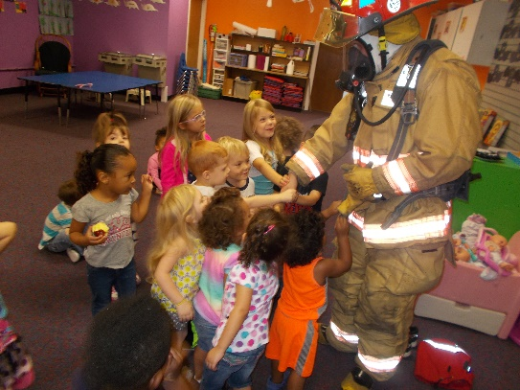

Thank you for your interest in Little Hands at Work and Play. We look forward to the opportunity to serve your childcare needs.

